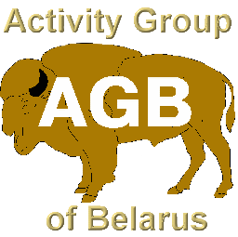
Instruction – Manual
For work and applications for awards
International club of AGB
In the EPC service

View AGB club JT-awards list

You can see the site of club AGB http://www.EV5AGB.com
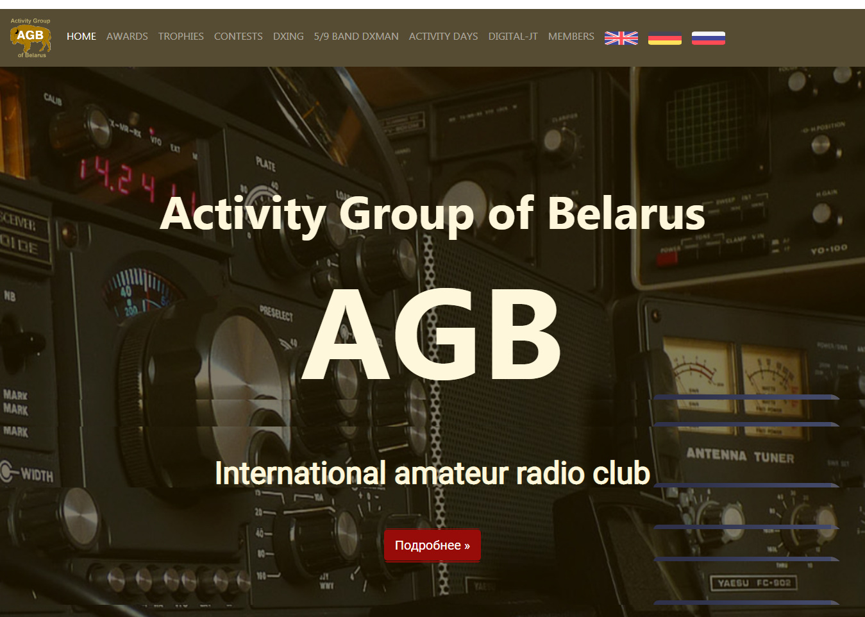

At the top of the page there is a MENU

You can choose Your language ( today Russian and English are working )

To view AGB-JT awards, press DIGITAL-JT in MENU
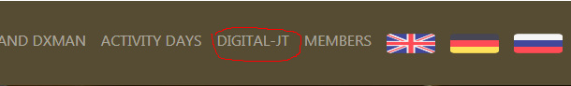

You will be taken to the section-block of the subject of awards
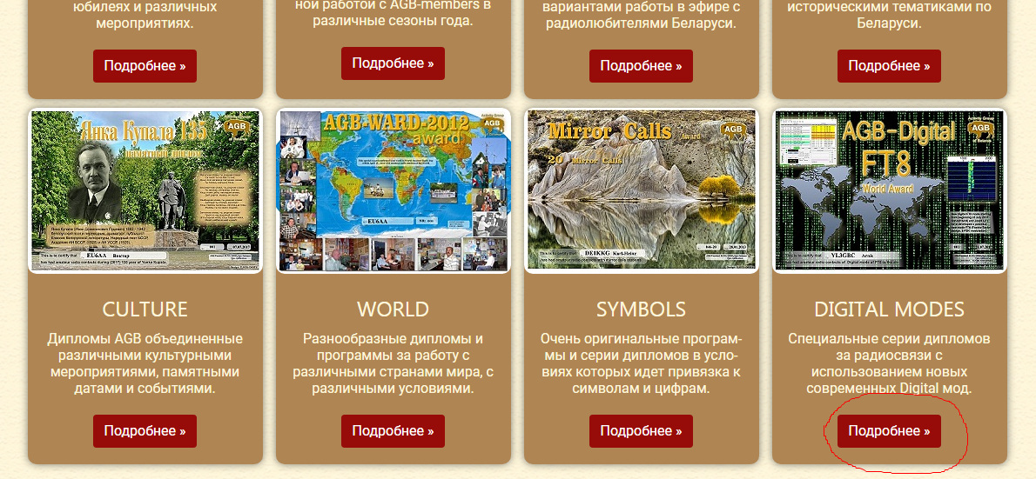

In block DIGITAL MODES press MORE INFO

You get to the page of AGB-JT awards

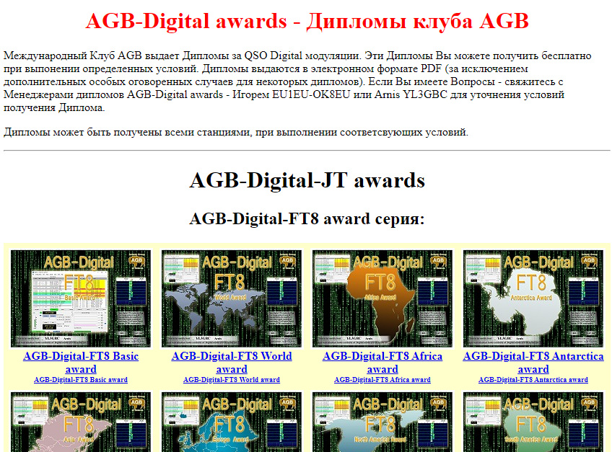

Here, awards are organized by topics, series and You can see awards visually ( by clicking on the award – in a new windows will open picture of award with higher resolution) and also click on the Name of award and go to the page with description of the award execution conditions.

Application form and Graduation of AGB-JT awards

To do this, we go to the EPC server https://epc-mc.eu/
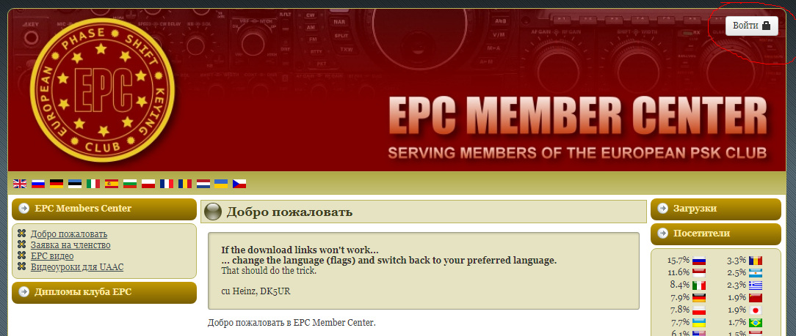

At the top right, click LOGIN and then register on enter Your data (login-password)
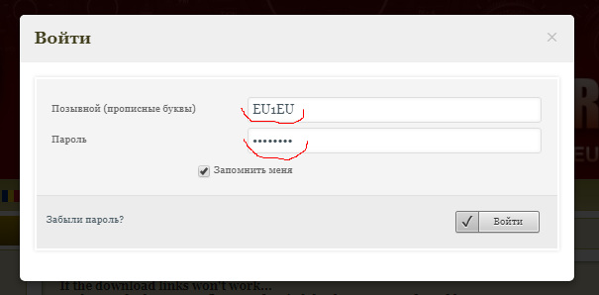

Once inside the site, in the Admin area, you select DOWNLOADS on the right and, expanding the menu, select UltimateAAC (UAAC) for your type of computer and download it to Your computer. Most now use Windows 64 bit
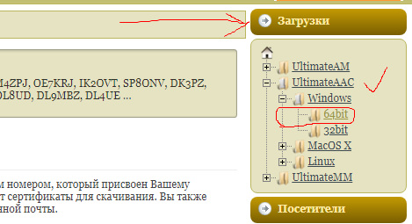

If you cannot click to open a new page, open through the right mouse button in another window.
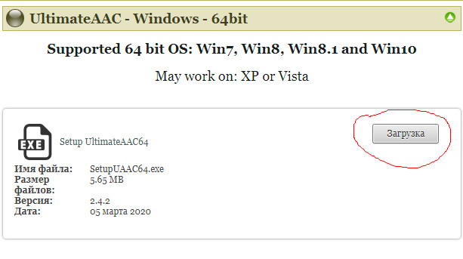

It is the UAAC program that you need to work with your ADIF log and apply for awards.

Install and work in UAAC

From the downloaded file, install UAAC on your computer.
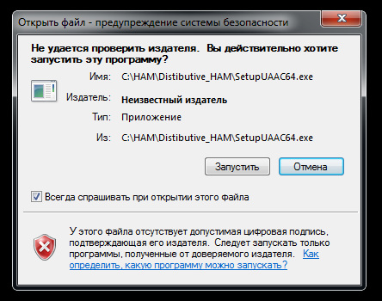

Select Your language
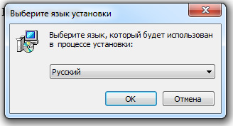

Choose Create a desktop icon (this is for your own good)
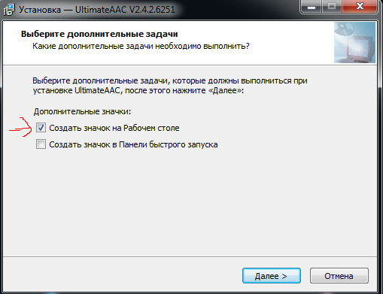

Next, continue the installation of the program.
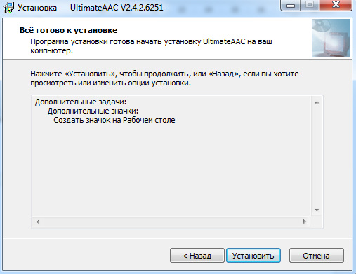

As a result, the UAAC icon will be on your desktop
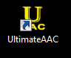

Launch the UAAC program. There is a very long process of importing the necessary data from the Internet for the program to work ... a few minutes ... Wait for the process, make yourself a cup of tea or coffee, and even better strudel to It )))
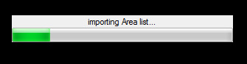

Such a window of the UAAC program will appear - select for the first inclusion, and also periodically check the ENTER button of your personal data.
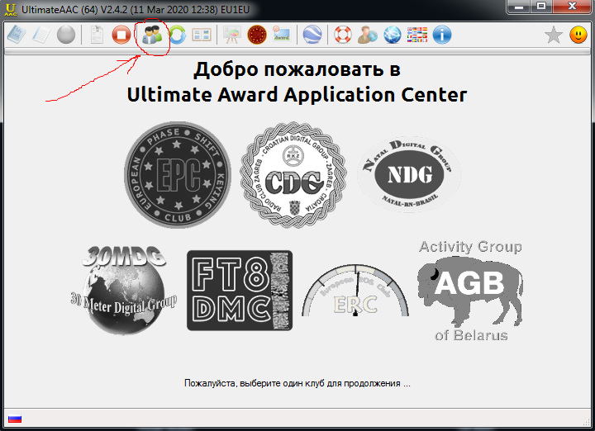
Fill in the data - Callsign, Name, email, and used variations of your callsign if you use them. It is for this your call sign. Do not forget to click SAVE.
*** For fans to run ahead of the engine - for your other callsign, you can also do such actions..
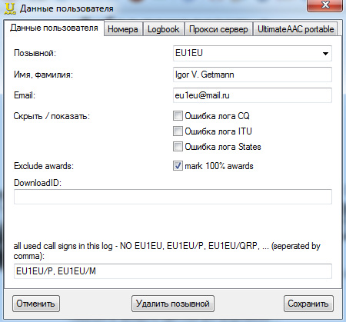

Next, go to the NUMBERS tab (these are your membership numbers in Clubs)
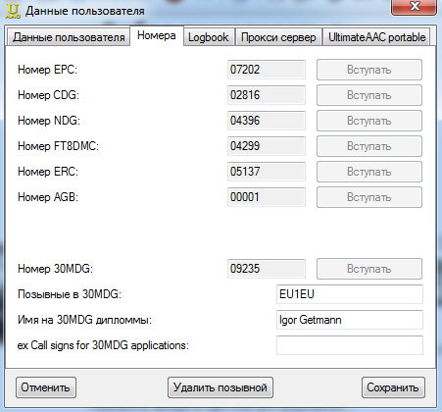
You can have only one Club - it doesn’t matter at this Stage. The main thing is you are in the Team.

How to get an AGB membership number and become an AGB-member read on the AGB Club page
http://ev5agb.com/club/membership.htm - here are Conditions for joining the AGB Club, there is a questionnaire and links to download the questionnaire, and there is also a feedback form, by filling out which, the data will be immediately sent to EU1EU to work and contact you.
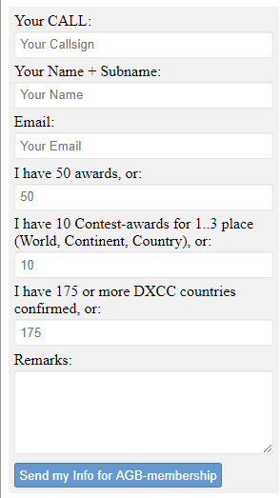

So, go to the next tab in UAAC – Logbook
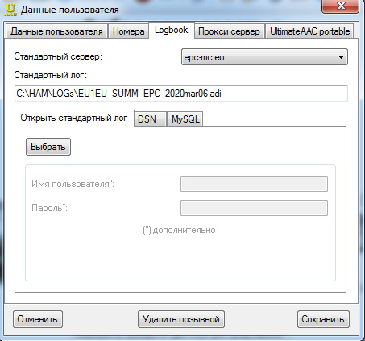

Choose Server (I recommend starting with the default one)
Next, select your ADIF file - where ALL of your QSOs are
Next, select your ADIF file - where ALL of your QSOs are
Proxy server and UltimateAAC portable tabs - you won’t need to start working, but you can and should use them (thanks to competent developers).

Finish working with your personal data and return to the main UAAC window
I recommend to do the Update - we expect - the process of work. Remember about coffee or tea.
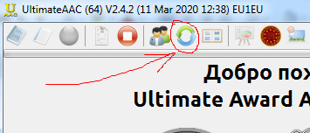

Next, choose a club - for example, our AGB
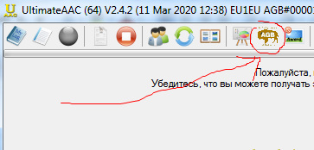

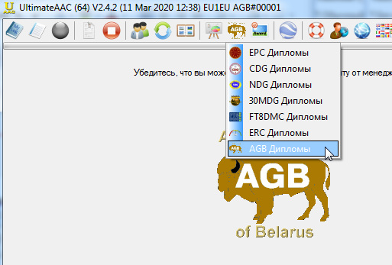

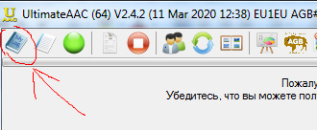
While we are working with the log and data, we again recall the strudel and coffee tea. )))
You will have a similar window - and the diplomas that you completed and can declare in green will indicate the APPLY button in the lower right
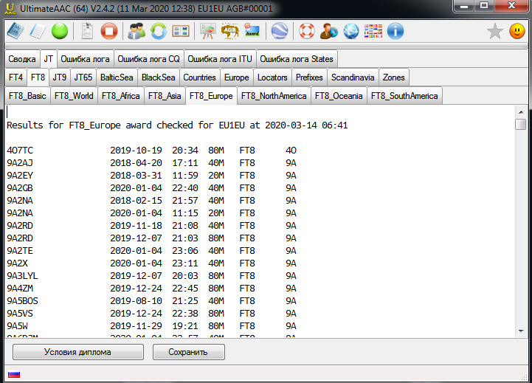

We have made applications for diplomas. Further, these Diplomas must be confirmed by the Managers of these Diplomas. For AGB Club, today the distribution of confirmation of diplomas in the EPC is made:
Igor EU1EU-OK8EU AGB#001 = FT8, FT4, Black Sea, Countries, Europe, Locators, Prefixes, Zones (14, 15, 16, 17, 18, 19, 20)
Arnis YL3GBC AGB#365 = JT9, JT10, JT65, JS8, Baltic Sea, Scandinavia
Confirmation time is usually 5-7 days.
*** I can say for myself, Igor EU1EU, I do CFM several times a day and the confirmation time is from 15 minutes to 2 hours in the daytime.
Addresses of managers:
Igor EU1EU = EU1EU@mail.ru
Arnis YL3GBC = YL3GBC@mail.ru
If you have suggestions and business thoughts, and possibly comments, send a letter.
You can also send an Application for Membership in AGB Club to EU1EU

A very useful button is MY AWARDS - this is a diploma status check
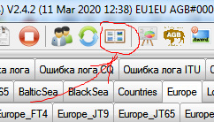
here you can see how things are with the completion of diplomas
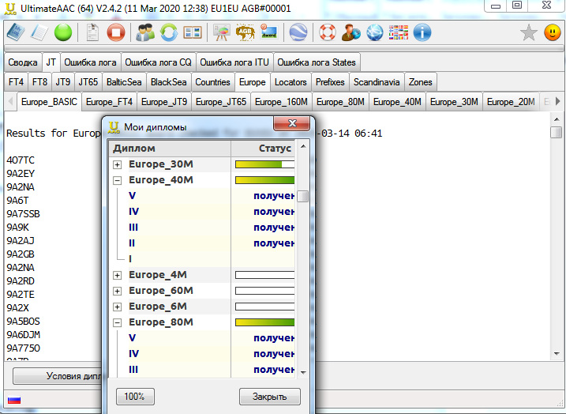

Thanks to This, you will see your “Weaknesses”

In more detail, we will periodically write UAAC opportunities and news about the new AGB Club Diplomas in the newsletter.

Now we have made a selection of Diplomas and have submitted Applications for Diplomas. Managers need confirmation, and you can download them to your computer.

Download AGB-JT awards to your computer

When applying for the Diploma you will receive an email about the acceptance of the application.
There is an ID code for downloading. Save it to Myself. You will need it.
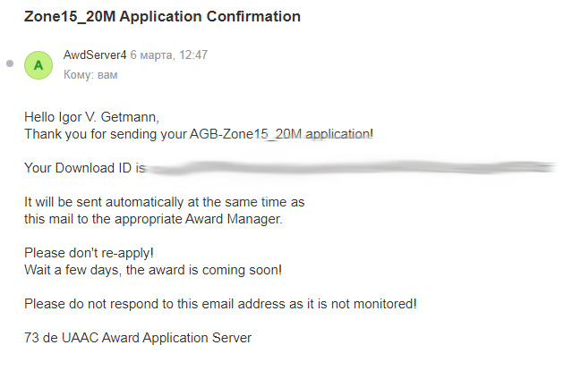
There are 2 ways to download AGB-JT Diplomas from EPC:
1 way - through the EPC server, going to it
https://epc-mc.eu/index.php?option=com_content&view=article&id=211&Itemid=345&lang=ru = on Russian
https://epc-mc.eu/index.php?option=com_content&view=article&id=211&Itemid=345 = on Your language
2 way - through the link on the AGB website
http://ev5agb.com/award-agb-digital/award_digital-jt.htm = on Russian
http://ev5agb.com/award-agb-digital/award_digital-jt_e.htm = on English

1 way - through the EPC server
Let’s go to EPC
https://epc-mc.eu/index.php?option=com_content&view=article&id=211&Itemid=345&lang=ru = on Russian
https://epc-mc.eu/index.php?option=com_content&view=article&id=211&Itemid=345 = on Your language

For this, you may need to have data to enter the site - login-password.
On the site page on the left menu, select CERTIFICATES -> AGB DIPLOMAS
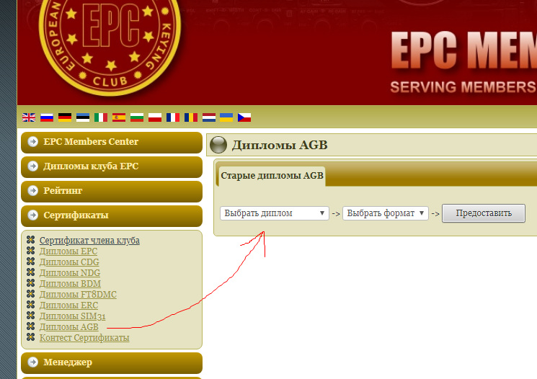
The next step - you will see the availability of diplomas that have passed CFM and are ready for pumping. Select the FORMAT to download (JPF - PDF) and then choose the TITLE of the diploma.
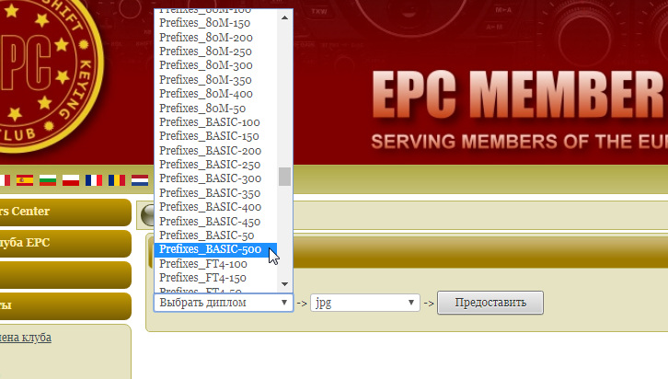

Choose diplomas one by one and download.
*** for those who like to run ahead of the engine - here you also want to pump out all the diplomas with one button. It already says "modern paranoia freebies." Remember the old days when you had to fill out an application for a Diploma (on paper, a certain form) to certify this application and then send it by mail. Expect. And having received a Large envelope or tube - Rejoice !!! That feeling is IMPOSSIBLE to compare with those smiles that are on the face when downloading a diploma. I suppose that part of the ham radio does not have a smile even when downloading. Other Times - Other Morals ...

Those diplomas that you have downloaded - on this page go into the status category - OLD AGB DIPLOMAS. It's comfortable. Anything can be and you can always deflate your Diplomas.

2 way - through the link on the AGB website

http://ev5agb.com/award-agb-digital/award_digital-jt.htm = on Russian
http://ev5agb.com/award-agb-digital/award_digital-jt_e.htm = on English
AGB-JT diplomas window opens and you follow the link

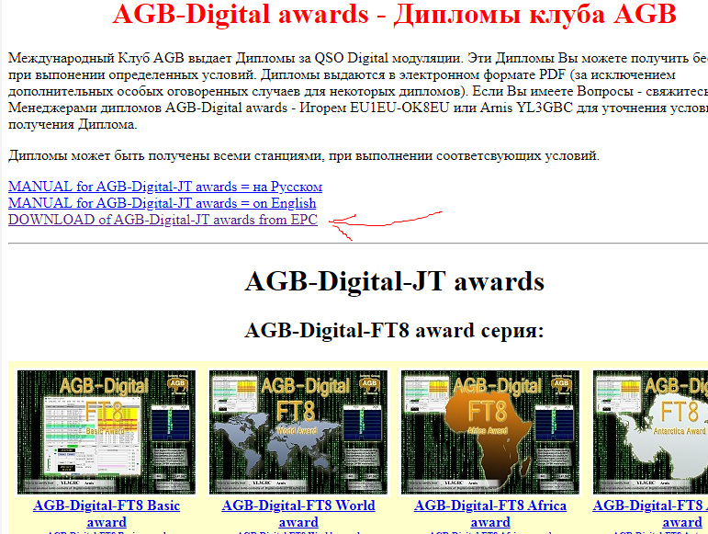
Page opens
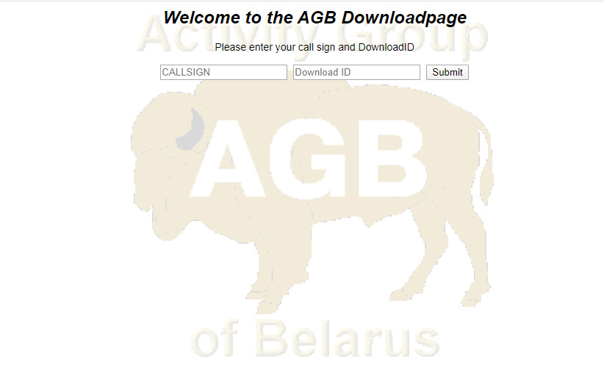

And you can enter your Call Sign and an ID code sent to you by email for downloading diplomas. I hope you remember, we talked about this)))

Page opens

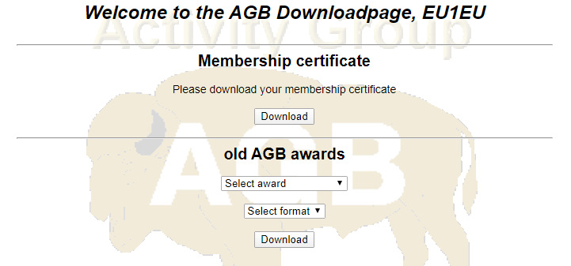

You can download your AGB-member Diploma Certificate
and also download AGB-JT Diplomas to your computer.

I am sure these methods will help you deflate your diplomas.

Let me remind you that the AGB Club diploma program is very large and we will expand and post diplomas on EPC as far as possible. Special Thanks Heinz DK5UR for Help and Cooperation !!!

A small section on how to apply for AGB-membership

On the page http://ev5agb.com/club/membership_e.htm describes the application options and the Club Membership Regulation.
Applications are in MS-WORD format in Russian, English and Czech.
Also in TXT format in Russian, English.
The page has an interactive form, filling in which the data will be immediately sent to EU1EU and will go to work. You will reduce the time.

The page has links to lists of AGB-members
• AGB member-list [Call -> Nr] Сортировка-индексация по префиксу позывных.
• AGB member-list [Nr -> Call] Сортировка-индексация по членскоми номеру.
This is what AGB-membership Certificate Diploma looks like
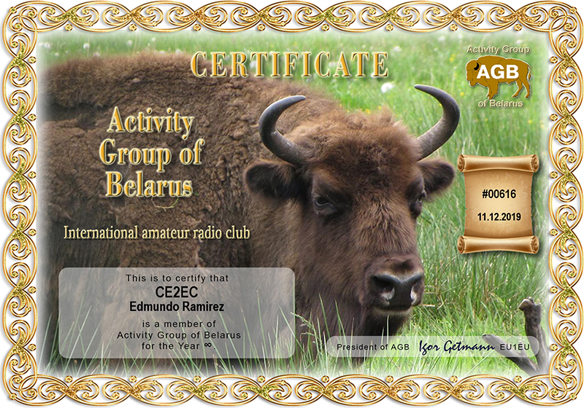

I am sure this MANUAL will help you to obtain AGB Club Diplomas.
And it will increase your Activity on the air and of course in JT-mods.
Please, if you are the correspondents with whom you have already worked, then they need you for some new Diploma. Make a QSO. And find out - maybe there is a new Diploma, there are Days of activity, a new interesting event.
See you live. 73 and of course 77 (the DIG (Diploma Interest Group) Club called it - “Successful Hunt for Diplomas and Trophy” more than 50 years ago)
Best regards,
Igor EU1EU
AGB#001 President of AGB club
www.EV5AGB.com
EU1EU@mail.ru

This MANUAL can be downloaded on the AGB Club website at
http://ev5agb.com/award-agb-digital/award_digital-jt.htm = on Russian
http://ev5agb.com/award-agb-digital/award_digital-jt_e.htm = on English

